# Question 1

### P + Lag Controller

What I first must do is study the bode plots of the plants given to us and use them to gain an understanding of the plant’s frequency response. From looking at plant’s magnitude response we see that the slop of the plants magnitude is 0dB/Decade at low frequencies. Therefore the plant is a 0 type controller. However at higher frequencies the magnitude begins to drop at a rate of roughly -20dB/decade, meaning the system is a second order system.

If we now consider the phase plot we note the final phase rests at a value of -180 $°$. This agrees with our assumption that the system is a second order system but also that there is no latency.

Moreover, as the magnitude plot never crosses the 0dB point, the phase margin of the system is infinite. The gain margin is also infinite.



Examining the magnitude plot, I note that the low frequency gain is approxiamtely -5dB. If we place the system in a unity negative feedback loop, and had a step input, the steady sate error would be:

$$k={10}^{-\frac{5}{20}}≈0.6$$

$$\frac{1}{1+k}=s.s error$$

$$\frac{1}{1+0.6}=0.625$$

$$steady state error=62\%$$

We know that when designing a controller it is imperative for the steady state error to be below 2.5%. Steady state error is always our first consideration when designing controllers. As such we will need to add a P controller to reduce our steady-state error.

$$\frac{1}{1+K_{total}}<0.025$$

$$\frac{1}{1+0.6\left(K_{p}\right)}<0.025$$

$$K_{p}>\frac{0.975}{0.015}≈65$$

Converting this gain to decibels gives us a gain of approximately 40dB. Therefore we will shift the entire graph up by 40dB using our P controller. We will then call this our augmented plant.

We must now consider our phase margin. In order to calculate this we must first calculate our damping ratio using the following formula:

$$PO≈100\exp\left(-\frac{πζ}{\sqrt{1-ζ^{2}}}\right)<30$$

$$ζ>0.358$$

$$ζ=0.4$$

This gives us a phase margin of:

$$PM≥100ζ={40}^{o}$$

Finally we must evaluate the systems natural frequency, $ω_{n}$:

$$\frac{4}{ζω_{n}}<2.4$$

$$ω_{n}>4.655 rad/sec$$

From this we can now calculate the gain crossover frequency of our new augmented plant, $ω_{gc}$:

$$ω_{gc}=ω_{n}\sqrt{\sqrt{1+4ζ^{4}}-2ζ^{2}}$$

$$ω_{gc}>4.1 rad/sec$$

Using the information found above I decided to choose the following values for my system:

$$PM={40}^{o}$$

$$ω_{gc}=6 rad/sec$$

Now if we examine our new Bode plots:

40



20

0

-20

We note the gain at our new gain crossover frequency ωgc is approximately 22dB. The phase at or gain crossover frequency is approximately -2o.

To attain the required system we must achieve the following:

$$Gain of Controller @ 6 rad/sec+Gain of Plant @ 6rad/sec=0$$

And

$$Phase of Controller @ 6 rad/sec+Phase of Plant @ 6rad/sec>-180°+PM\left(40°\right)=-140°$$

I decided to choose a lag controller to achieve these specifications. It is clear tha the gain of our lag controller must be:

$$-20\log_{10}\left(α\right)=-22dB$$

$$α≈12.59=12.6$$

We require a phase of 6 rad/sec in the high frequency range of the lag controller. Therefore:

$$\frac{10}{τ_{lag}}<6$$

$$τ>1.667$$

$$τ=1.7$$

Therefore the structure of our lag controller is as such:

$$G_{lag}\left(s\right)=\frac{1+τs}{1+ατs}=\frac{1+1.7s}{1+21.42s}$$

Combining this lag controller with the P controller we used earlier we attaint he following coltroller transfer function:

$$G_{c}\left(s\right)=\frac{40\left(1+1.7s\right)}{1+21.42s}$$

Plotting the Bode plots of just the controller we see that this meets our frequency gain and phase requirements. As a result I assume it also meets the original systems requirements.

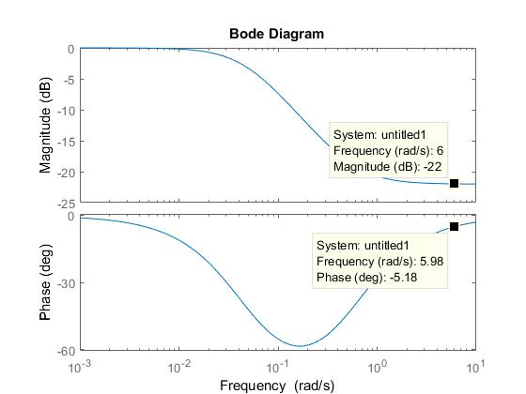

# Question 2

### Part 1 – Transfer function

The following are the Bode plots of a high frequency cutting machine. We have been tasked with calculating the transfer function of this machine.



The easiest way of calculating the transfer function of this entire system is first to divide it into sub-systems, calculate their transfer functions and then combine these transfer functions at the end.

Our fist transfer function will deal with the low frequencies. We note that at low frequencies the magnitude drops steadily at a rate of approximately -20dB/decade. Therefore I conclude there must be a pole at s=0. Furthermore if we examine our phase plot we note that at low frequencies the system has a constant phase of -90 $°.$ This validates our assumption of there being a pole at 0. Therefore my first sub-systems transfer function looks like this:

$$G_{1}\left(s\right)=\frac{1}{s}$$

The next point of note is at approximately 1200 Hz. The magnitude spikes at this point before acquiring a slope of -60dB/decade. The phase at this point also drops rapidly from -90 $°$ to -270 $°.$ This change in phase and magnitude has all the characteristics of a pair of complex conjugate poles centred at 1200Hz. They have the following transfer function:

The next noticeable point is at approximately 1200 Hz. At this point on the phase plot, we can see that the system drops from -90o to -270o. We can see that at the amplitude spikes near this spot, before acquiring a slope of -60dB/decade. This is the characteristic of a complex conjugate pair of poles. The transfer function for this would be the following form:

$$G_{2}\left(s\right)=\frac{{\left(1200×2π\right)}^{2}}{s^{2}+2ζ_{1}\left(1200×2π\right)+{\left(1200×2π\right)}^{2}}$$

After experimenting with different values of $ζ_{1},$ the damping factor of this subsystem, I discovered that the value that gave me the best representation of the spike was 0.04.

In the fourth sub-system we note that there is another complex conjugate pair of poles at 3000Hz. Applying the same techniques as above I found that the closest approximation for $ζ$ was 0.01. This gives us the following transfer function:

$$G_{4}\left(s\right)=\frac{{\left(3000×2π\right)}^{2}}{s^{2}+2ζ_{3}\left(3000×2π\right)+{\left(3000×2π\right)}^{2}}$$

In between the two complex conjugate pairs there is a sharp drop, consistent with a pair of complex conjugate zeroes. This is centred at around 2500Hz. We see the magnitude response drops sharply at this point, as a result of the complex conjugate pair of poles, but then rises sharply at a value of approximately 60dB/decade. The phase also increases steeply from approximately -270 $°$ to -180 $°$. These are all characteristics or a pair of complex conjugate zeroes and so validate our assumption. Complex conjugate zeroes have the following transfer function:

$$G_{3}\left(s\right)=\frac{{(s}^{2}+2ζ_{2}\left(2500×2π\right)+{\left(2500×2π\right)}^{2}}{{\left(2500×2π\right)}^{2}}$$

Again testing different values for $ζ_{2}$ I found that the closest approximation was 0.09.

Examining our magnitude graph at higher frequencies we see that the magnitude is falling with a slope of -60dB/decade. This usually would indicate a third order system however if we look at our phase plot we note that the system does not have a phase shift of -270 $°$ at these frequencies. Therefore we can conclude that latency must be present and so we must allow for that in our system. We note that the degree of our latency is quite small, however it can be calculated using the following equation:

$$Phase=-\left(n-m\right){90}^{o}-ωL\left(\frac{{180}^{o}}{π}\right)$$

Where L is the latency. If we take the following, round values for the phase:

$$@5000 Hz=-{370}^{o}$$

$$@10,000 Hz=-{450}^{o}$$

Then we can calculate that:

$$-{370}^{o}+{450}^{o}=\left(-5×{10}^{3}×2π\right)L\left(\frac{{180}^{o}}{π}\right)+\left(1×{10}^{4}×2π\right)L\left(\frac{{180}^{o}}{π}\right)$$

$$L≈-5×{10}^{-5}sec$$

This latency then provides us with a fifth and final subsystem, with the following transfer function:

$$G_{5}\left(s\right)=e^{-5×{10}^{-5}s}$$

Now we must calculate the gain of the entire system. We do this by getting the bode plots of the system without the gain.

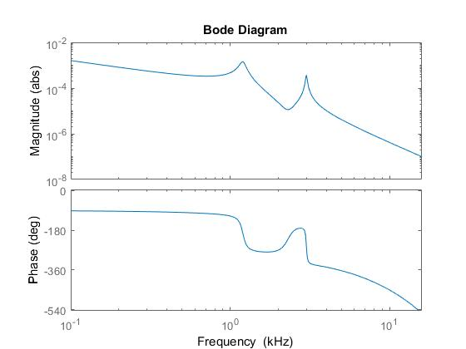

We note that the gain is approximately 2000 below that of the Bode plot given to us in the lab handout. Therefore we must assume there is a gain of 2000.

$$gain=2000$$

Finally we can combine the gain and the 5 subsystems transfer functions, to get the final transfer function of the entire system:

$$G_{p}\left(s\right)={gain×(G}_{1}\left(s\right)G_{2}\left(s\right)G_{3}\left(s\right)G_{4}\left(s\right)G_{5}\left(s\right))$$

$$G_{p}\left(s\right)=\frac{(2.02×{10}^{16} s^{2} + 5.254×{10}^{19} s + 4.218×{10}^{24}{)e}^{-5×{10}^{-5}s}}{2.088×{10}^{8} s^{5} + 2.047×{10}^{11} s^{4} + 8.612×{10}^{16} s^{3} + 4.923×{10}^{19} s^{2} + 4.218×{10}^{24} s}$$

I then plotted this this transfer function’s Bode diagrams. We note that the y axis on the magnitude graph has now changed to decibels, and the frequency of both graphs is now measured in rad/sec instead of Hz.

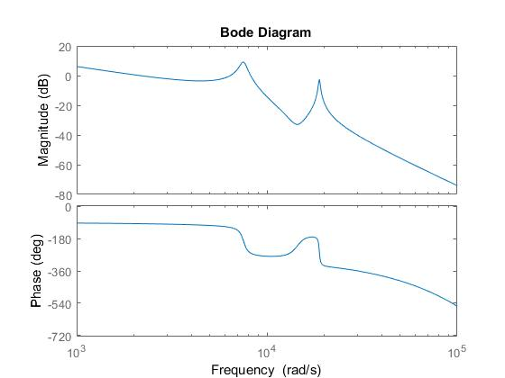

I believe this is a fairly accurate representation of the system.

### Part 2 – Controller

We were then asked to design a controller for the system. Our first requirement was for the closed loop system to track a step input with zero error, however as the plant already has a pole at 0 this has already been achieved.

If I then consider the 2% settling time of my system must be below 0.8 seconds, I conclude that the best way to do this would be by designing a zero-pole controller, as a lag controllers response would be far too slow.

Using the requirement for my percentage overshoot I can calculate an acceptable value for my damping ratio, $ζ:$

$$100\exp\left(-\frac{πζ}{\sqrt{1-ζ^{2}}}\right)<60$$

$$ζ>0.1602$$

I felt a suitable value for my damping ratio would be:

$$ζ=0.20$$

We can use this to calculate the Phase Margin:

$$PM=100ζ={20}^{o}$$

And the natural frequency, $ω_{n}$:

$$\frac{4}{ζω_{n}}<0.8$$

$$ω_{n}>25$$

$$ω_{n}=35 rad/sec$$

Using our newly calculated values we can find the required value for our gain crossover frequency:

$$ω_{gc}=ω_{n}\sqrt{\sqrt{1+4ζ^{4}}-2ζ^{2}}$$

$$ω_{gc}≈33.629 rad/sec$$

$$ω_{gc}=34 rad/sec$$

Examining the Bode plots once more we note that at our required gain crossover frequency the magnitude of the system is 35dB. Therefore our controller must have a gain of -35dB at 34 rad/sec.

The phase at $ω_{gc}$, our gain crossover frequency must be:

$$Phase of Controller @ 34 rad/sec+Phase of Plant 34rad/sec+required phase at ω_{gc}>-180°+PM\left(20°\right)-90°=-70°$$

Zero-pole controllers have the following form:

$$G_{c}\left(s\right)=\frac{k\left(s+z\right)}{s+p}$$

From this and the values found above we obtain the following requirements:

$$k\left|\frac{j35+z}{j35+p}\right|=0.02$$

$$Arg\left(j35+z\right)-Arg\left(j35+p\right)>-{70}^{o}$$

Furthermore as we want our poles and zeroes to lie in the left hand plane we can state that z and p must be positive. Therefore :

and < 90o.

Choosing that the argument of is 60o and the argument of is 20o, we get a value for z of 100 and p would equal 20. Therefore:

$$k\left|\frac{j35+100}{j35+20}\right|=0.02$$

$$k=\frac{0.02}{2.6282}=0.0076$$

These values give us the following transfer function:

$$G_{c}\left(s\right)=\frac{0.0076\left(s+100\right)}{s+20}$$

Placing our plant in series with our controller we obtain the following Bode plots:

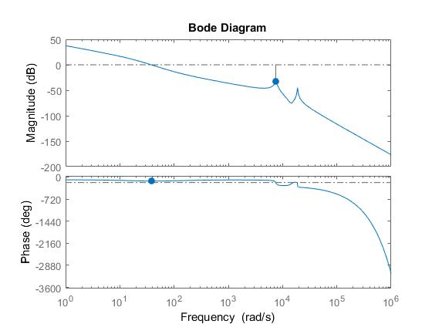

We note that the phase margin at $ω_{gc}$, our gain crossover frequency is now approximately 49 $°$. This value is well above our allowable value of 20 $°$. This will give us a stable closed loop system.

Now if we examine the closed loop system’s step response we can see if we have met the design specifications:

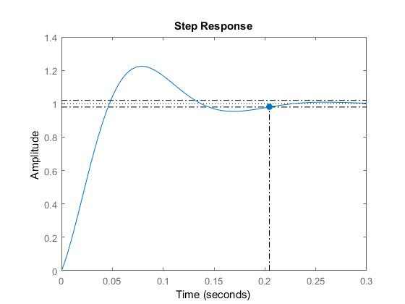

Straight away we note that the system has zero error at steady state. It’s 2% settling time is also much lower than the 0.8 second limit at just over 0.2 seconds. We were given a tolerance of 60% for our percentage overshoot, and the system is well below that at 22.5%.

As such we can conclude that the system does in fact meet all the specifications.